**Firebase introduction and setting:**Firebase: Google's mobile platform that helps you quickly develop high-quality apps and grow your business.

Stages:

1. Enter firebase and make an account (on your base google account): <https://firebase.google.com/?gclid=CjwKCAjwxt_tBRAXEiwAENY8hVPA_bSTU_Q9k_wS-52kj-K8zzqrUFYAdD4H3VtoDnDfuI_caG0eXBoCL9gQAvD_BwE>
2. Press the get started:

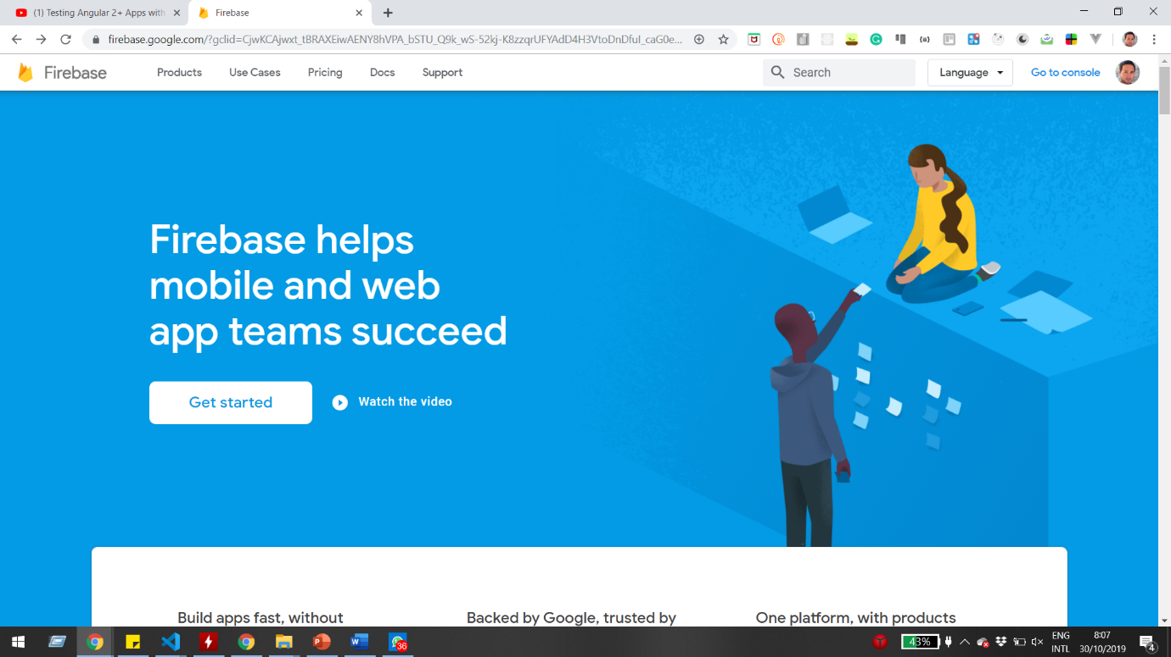

1. Add a project:

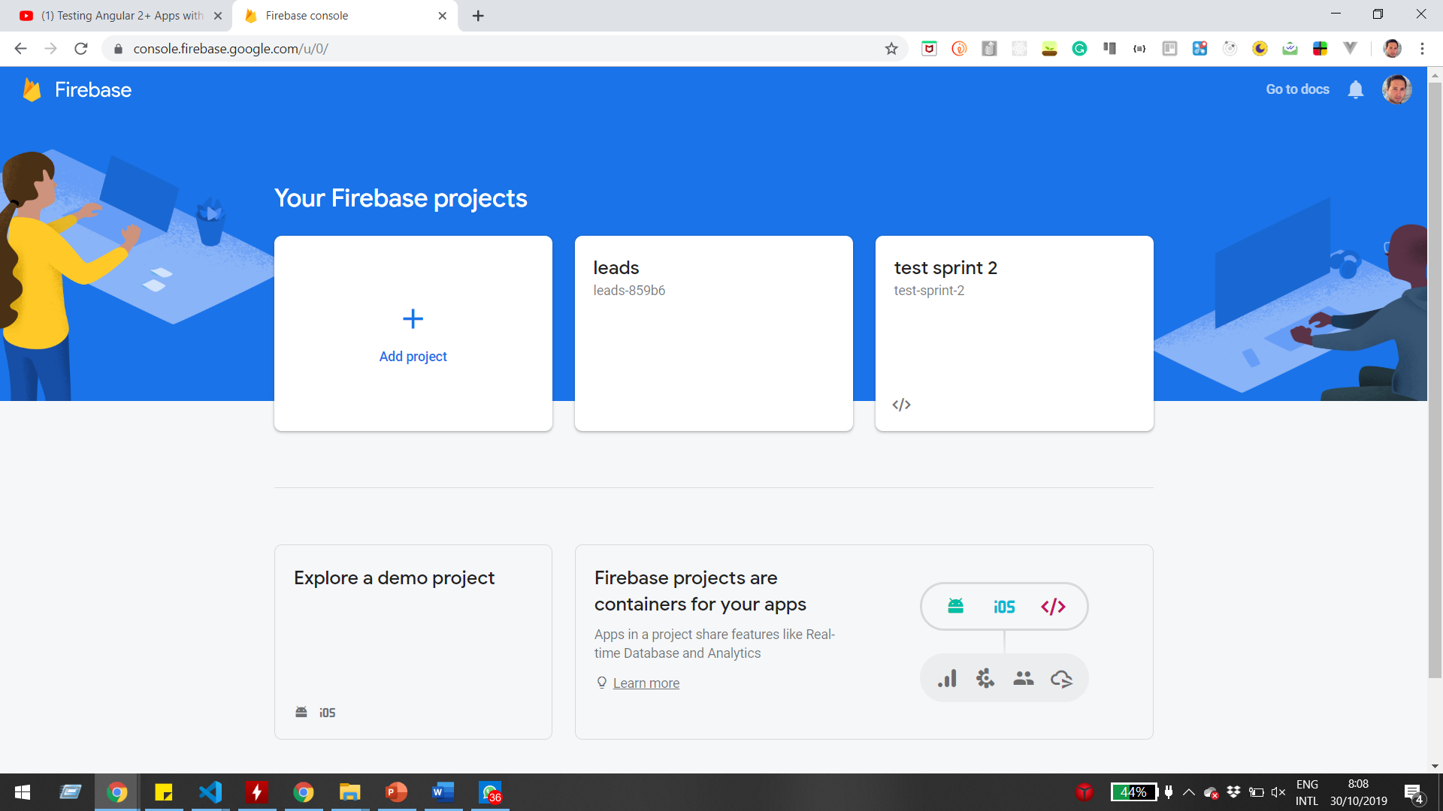

1. Give the project a name (and remember the project ID):

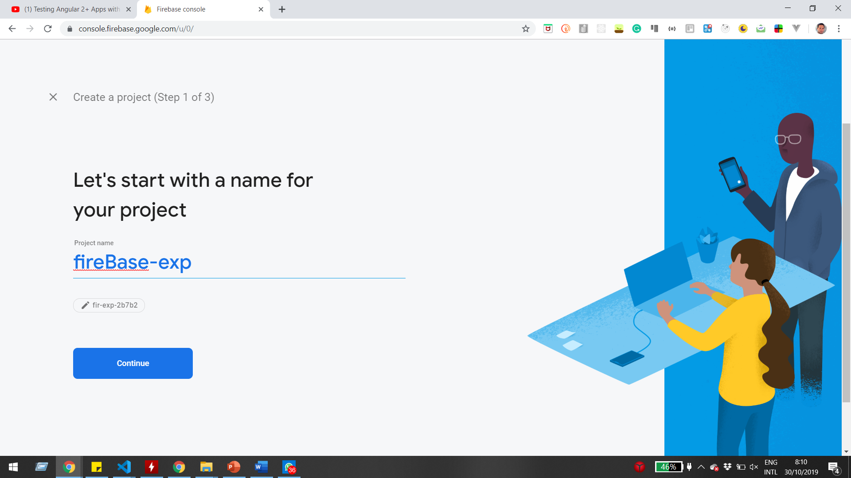

1. Select enable google analytics and Press continue

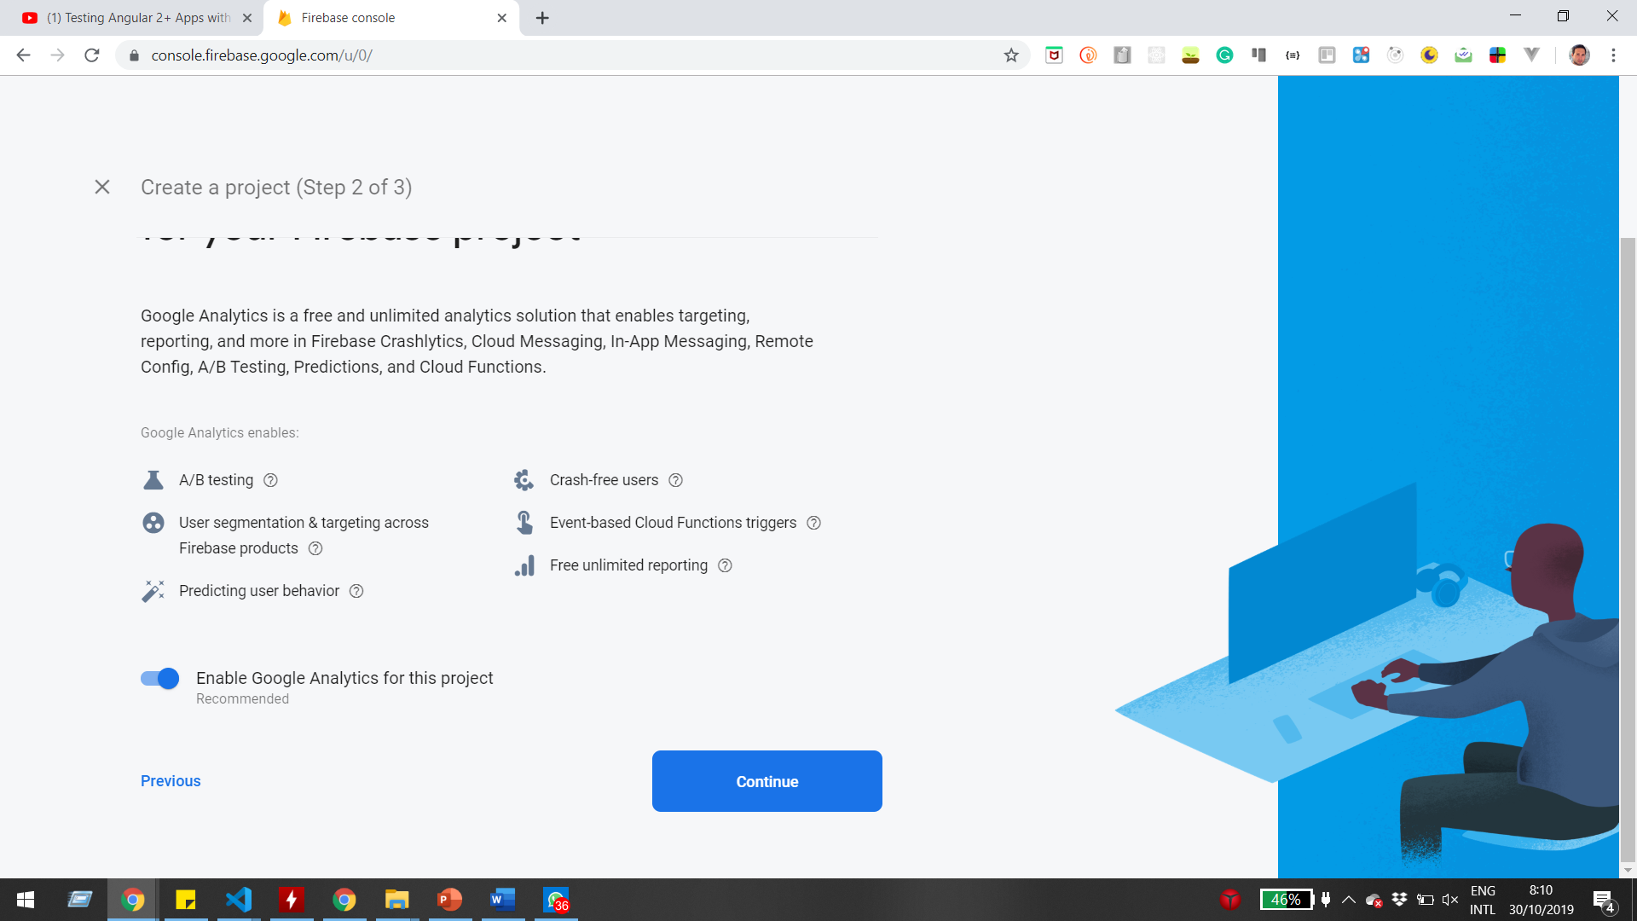

1. 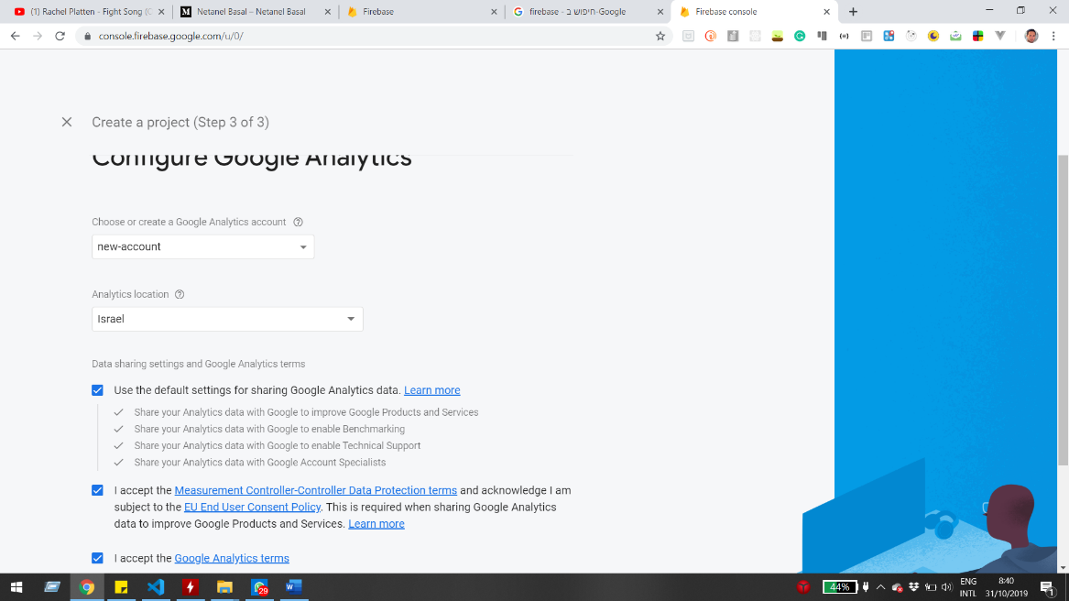Create google analytic account and press continue.
2. Wait for the project creation.
3. Press DataBase and create DataBase (in test mode).
4. Press rules and change both read and write options to true.
5. Update the send info url into one containing your project ID.

var baseURL =https://[your project id].firebasio.com

Exmaple: var baseURL = 'https://fir-dcced.firebaseio.com';

1. After sending the form you can go check the data, you should see it filled, for example:
2. 